Cleaning and storing catheters, syringes and cones

Guidelines for nurses

© Child-Help International & SHARE Knowledge Centre

- Cleaning and storing the catheter and syringe

- Wash the outside of the catheter with water
- Rinse catheter 3 times with water and blow air through to remove excess water
- Shake the catheter as dry as possible, leave it to dry in the sun when possible and store inside a washed piece of cloth, iron the cloth beforehand
- Syringe: wash with water and blow out with air and store the parts disconnected from each other
- Catheters should be replaced every 3 months

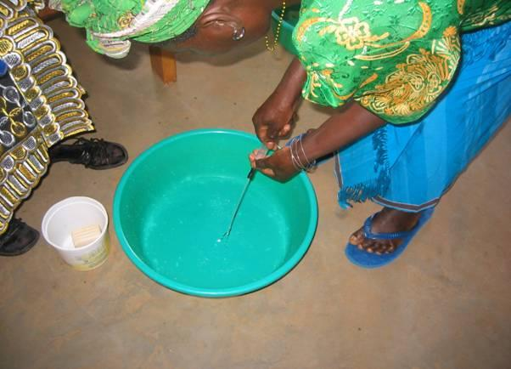
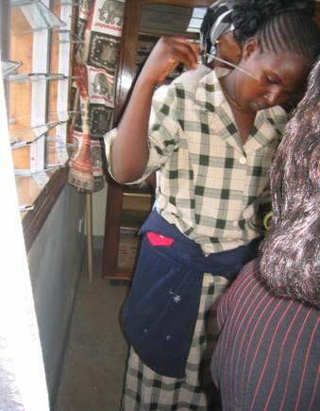

- Bowel washout set: cone + bag + tube

A good maintenance of the washout set prolongs the life span of the material and avoids infections.

- A bowel washout sets consists off:
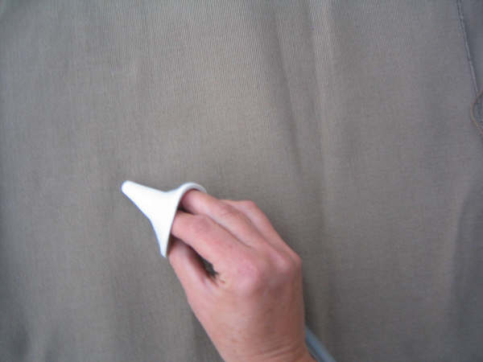
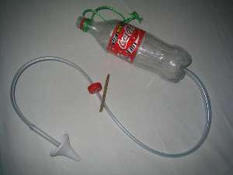
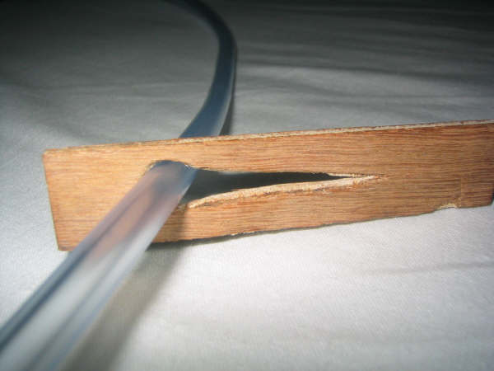

Cone Tube with clip complete set with reservoir

- Cleaning after every use:

- Clean all parts of the set after every use: wash with water and soap and rinse thoroughly with water
- Dry all parts thoroughly after every use

- Periodical cleaning:

- To avoid fungus, it is advised to clean the sets more thoroughly every month.
- Use a solution of water with bleach/chlorine
- Rinse with clean water and let dry thoroughly.

