Technique CIC

Training booklet for nurses

© Child-Help International & SHARE Knowledge Centre

- Goals of CIC

- To prevent bladder infection by avoiding residual (urine staying in the bladder)
- To avoid unsafe bladder pressure by frequent catheterization
- To achieve social continence

- Material

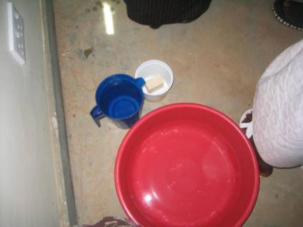
- Catheters
- KY Jelly for boys, if necessary a mirror for girls
- Something to collect the urine into
- Pieces of cloth to wash genital area
- Water, soap, bowl to wash hands
- Latex free gloves for community workers
- Use of correct catheter size according to age
- Use of correct catheter per age

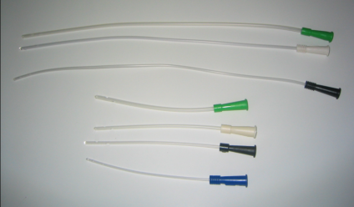
- Use the largest catheter that can enter the urethra
- Short catheters for girls’ and baby boys’
- Boys’ from 5 years on use the long catheters

- Technique

- Explain the importance of CIC and the technique in a simple way to the parents and the child

Technique:

- Cleaning hands

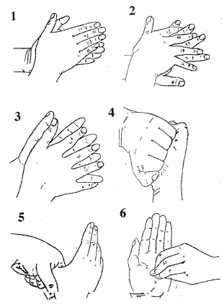

- Clean genital area

- Daily 1x with water and soap
- At every soiling or bowel movement
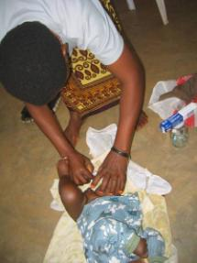
- Always wash from above to below to avoid bacteria from the bowel being brought forward to the urethra
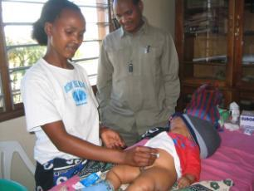
- Change piece of cloth for each wiping action

- Insertion of the catheter

- Use the widest catheter that can enter the urethra without force
- For boys: place gel on the back of the hand and slide the catheter from the tip through the gel to coat the catheter well (if Gel is not available use sunflower oil on the palm of the hand)
- For girls: spread labia so that the urethra is clearly visible (no gel required)
- Advance the catheter into the urethra until urine is flowing out, push the catheter slightly further in the bladder to make sure both holes are into the bladder
- Let the urine flow, when the urine stops to flow, push above the pubis
- Withdraw whilst turning the catheter slowly and stop when there is no more urine coming out
- Put the catheter again a little bit deeper and withdraw again until the bladder is empty
- Remove catheter and wash your hands

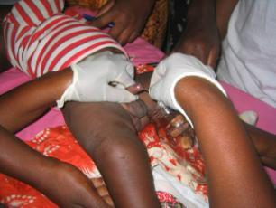

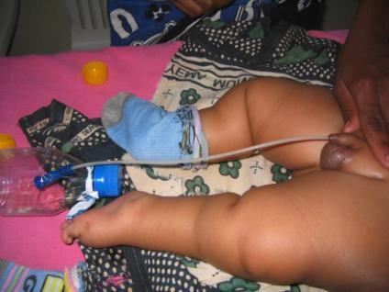

The bladder needs to be completely empty!

- CIC for girls

- Show a clear picture of a vulva and let the patient look at her own vulva so that she knows where the urethra is situated
- Learn to catheterize with the help of a mirror or learn to catheterize by feeling with the fingers
- Execute the technique just like explained above in section 3.

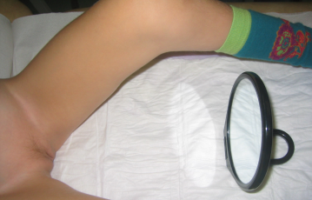
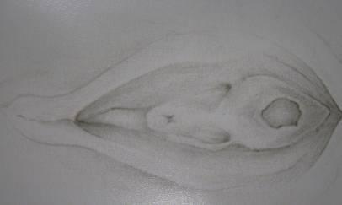

- CIC for boys

- Show a picture showing the path of urine from the tip of the penis towards the bladder
- The penis has to be held in the direction of the belly to bring in the catheter easier
- There can be felt counter-pressure at the constrictor at the level of the base of the penis
- Execute the technique as described above in section 3

- Examination urine

- Clear urine = no infection
- cloudy or strong smelly urine, blood in urine or more than normal wet in between = signs of infection

At infection:

- Empty the bladder well
- Have the boy / girl drink extra
- If possible use bigger CH
- If urine is still cloudy after 24 hours, start Nitrofurantoin

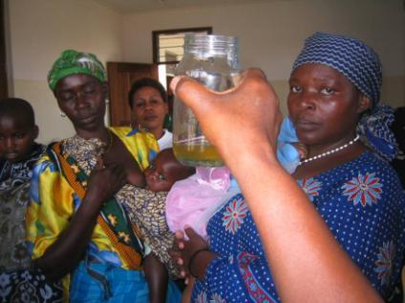
- Cleaning and storing of the catheter

- Wash the outside of the catheter with water and flush the inside with water using a syringe
- Rinse catheter 3 times with water and blow air to remove excess water
- Shake the catheter dry, leave it to dry in the sun when possible and store in a clean bowl or inside a clean piece of cotton cloth

(Not in the bowl used to collect the urine)

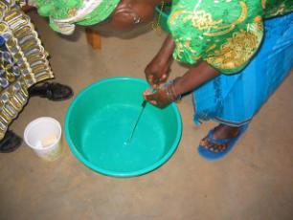

- Note data

- Note down the urine volumes during 5 days before the next consultation and note down if there is wetting in between CIC
- Urine volumes give information on the behaviour of the bladder
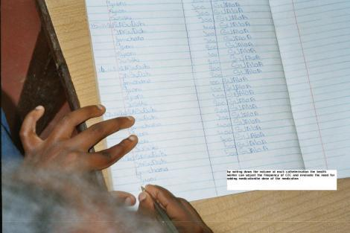

- Making a measuring cup

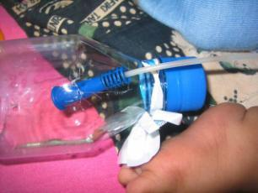
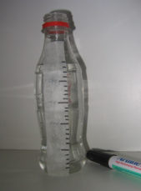
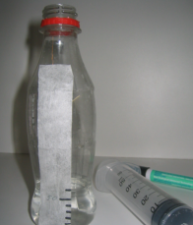

- Fill in empty drinking bottle 10ml at a time and put a mark for each 10ml
- Mark all 5Oml clearly
- If necessary make a gap at the top of the bottleneck to lay down the catheter during catherization

